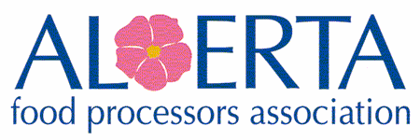
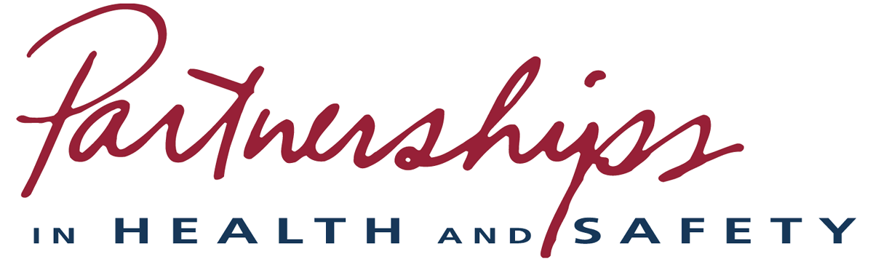
Workplace Health & Safety Course Schedule – 2024
All currently Virtual Instructor Led – If looking for in person training advise us or consider our onsite option.

OH&S System Building* - 2 (full) days | March 6-7  Sept 11-12
OHS Roles & Responsibilities for Managers & Supervisors – 1 (full) day | March 20  April 17  May 15  June 12  July 17  Aug 21  Sept 24
Hazard Assessment & Control – appox. 6 hr. format | June 4  Aug 7
Incident & Accident Investigation – approx.. 6 hr. format | June 6  Aug 14
Safety Auditor - 2 (full) days (Pre-requisite, OH&S System Building) | May 7-8  Fall date TBD
Safety Auditor Re-Certification – approx. 6 hr. format | June 19  Sept 18
HS Committee or Rep. ‘Technical Rules’ approx. 6 hr. Content  [Dec 2021 - Under OHS all HSC members or Rep. must be trained] | March 27  April 24  May 29  June 26  July 24  Aug 28  Sept 26

Indicate the DATES you are REGISTERING for send to info@afpa.com or AFPA 5123 Marian Road NE Calgary, AB T2A 2Y1

IN PERSON CLASS: /person (includes lunch)
Prices do NOT include GST #10669-3377-RT
Public course start time is 8:30am
1 day = $475 6 hr. format = $325 2 day = $750

VIRTUAL (Zoom): /person – electronic manuals included (+$35 for a printed version sent upon request)
1 day = $350 6 hr. format = $250 2 day = $600
Cancellation policy – reg. fees less $50 will be refunded if notified in writing 10 days prior to course. No refund will be made after that date but substitutions welcome

Student__________________________________________________Email:________________________________

Company____________________________________________Contact____________________________________
(if different from student)

Email________________________________________________________ Ph_______________________________

Questions? Help to build your program, Onsite training or the COR/Partnership programs 403.201.3657 or info@afpa.com

Check One | Method of Payment | Total
 | Cheque or E-Transfer or EFT (accounting@afpa.com)
 | Credit Card #: Expiry: CV#:
 | Invoice Us: (AFPA Members only) – provide a P.O. if required

If you do not receive acknowledgement within a few days, resubmit. You will be notified of course details 1 week prior to course date.
AFPA is a Certifying Partner for the food, beverage & allied industries & offers the Partners program for achieving your Certificate of Recognition (COR). You do not have to be registered in our Partnerships program to benefit from our Health and Safety training! There is no reason why you and your employees cannot enjoy the benefits of our great safety training. -Raise staff morale, heighten employee awareness, lower your lost time claim rates, save money on lost time, property damage, losses & injuries that result from workplace incidents.
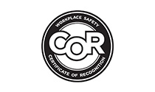

OH&S System Building - teaches how to properly develop, build and implement your health & safety management system.
- Company H&S policy and management commitment; Hazard identification and control, risk management; Inspection programs, Incident Investigation; Worker orientations, training, competency, and emergency response training. Program administration; H&S Committees, Other Parties, Legislation & Developing a health and safety manual.
-Option: AFPA builds you a customized, compliant company H&S program/manual - contact AFPA for details.

Safety Auditor - Provides a background in the basic principles & practices in the Partnerships audit process. Enables you to use the Partnerships Audit Instrument as a base for planning, executing, & reporting on your health & safety program. Ensures participants understand their roles & the purpose of audits in general & audits within the Partnerships program in particular. Students must have successfully completed the OH&S System Building course as a mandatory pre-requisite. [Recertification required every 3 years]

Hazard Assessment* – Identifying hazards, evaluating the risks presented by them & controlling each hazard before it injures someone, causes property damage, or interferes with your company’s work is a mandatory requirement in Alberta, regardless of your company’s size. This course includes: Introduction to hazard identification; assessment, evaluation, & control; hazard reporting; developing required documentation, how to conduct the following types;
- Routine Hazard Assessments, Controls, required reviews and documentation; Field Level / Site Specific, Non-Routine Hazard Assessments; When Equipment or Processes are New or Changed & Evaluating Controls, Hazardous Products & Materials

Incident & Accident Investigation* – Investigating incidents & accidents to learn from them, to make improvements and to prevent them from recurring.
- Initial response to incidents/accidents, controlling the scene, legal obligations of Supervisors to investigate;
- Collecting/protecting evidence and information, interviewing witnesses, due diligence, dealing with media;
- Analyzing the information, ensure reporting protocols and required documentation; Determining basic, immediate, and root causes, related factors/considerations, evaluate; Temporary and long-term corrective actions, to communicating findings at all levels; Incident Investigation kit (do you have one? what do you need to have? where will it be located?)

Roles & Responsibilities for Managers & Supervisors* – learn what the key elements are to a health and safety system; to understand you have ethical, moral & legal obligations to OHS, to what your roles & responsibilities are within the scope of these elements and the Alberta Occupational Health & Safety Act, Regulations and Code; to identify the underlying factors which affect the implementation of a health & safety management system, competency, directing the work of others and to set them up for success. [Management Commitment; Hazard Identification, Assessment & Control; Workplace/site Inspections; Qualifications, Orientations & Training; Emergency Response, Incident Investigation, Program Administration, H&S Committee/Rep, and Other Affected Parties] *Part of Supervisory competency requirements, or for anyone ‘who directs the work’ of others, by any title*

Health & Safety Committees/Rep – ‘Technical Requirements & Rules’ training for the development, implementation and/or ongoing maintenance of an effective H&S Committee (HSC). Includes: clearly defined roles, responsibilities, functions and having a Terms of Reference. This training, for all HSC members or HS Rep provides participants with an insight to their actual duties, responsibilities, key industry standards, communications, company obligations and compliance to applicable Ab. OHS legislation.
- Topics Covered include:
  - Purpose & Goals; What is a H&S Committee-Members; Worker’s 3 OHS Rights;
  - Benefits of a H&S Committee/Rep; Basic H&S Duties and Responsibilities;
  - Committee Functions; Meetings; Quorum; Agendas; Minutes; and Maintain Records;
  - Sequential Procedures for Making Recommendations to Management; Dispute Resolution;
  - Measuring Committee Effectiveness; Other Affected Parties as defined by OHS Act
  - OHS Competency Criteria; Undue Hazard; Work Refusals;
  - Sample templates of a Terms of Reference, Agenda, Minutes, Recommendations and more!

WHMIS 2015 – ‘free to members’ Work Hub online self-paced training (& management system) - especially for the office, sales or driver’s, etc. -All staff, regardless of position must have completed the new WHMIS 2015 training – no exceptions.
A Better Way to Manage Workplace Compliance (workhub.com) or info@afpa.com

Psychological Awareness, Disability Management/Return to Work & Modified Work training/workshops is available ‘free’ from Ab. WCB - https://wcb.ab.ca/resources/for-employers/seminars-and-workshops/index.html

